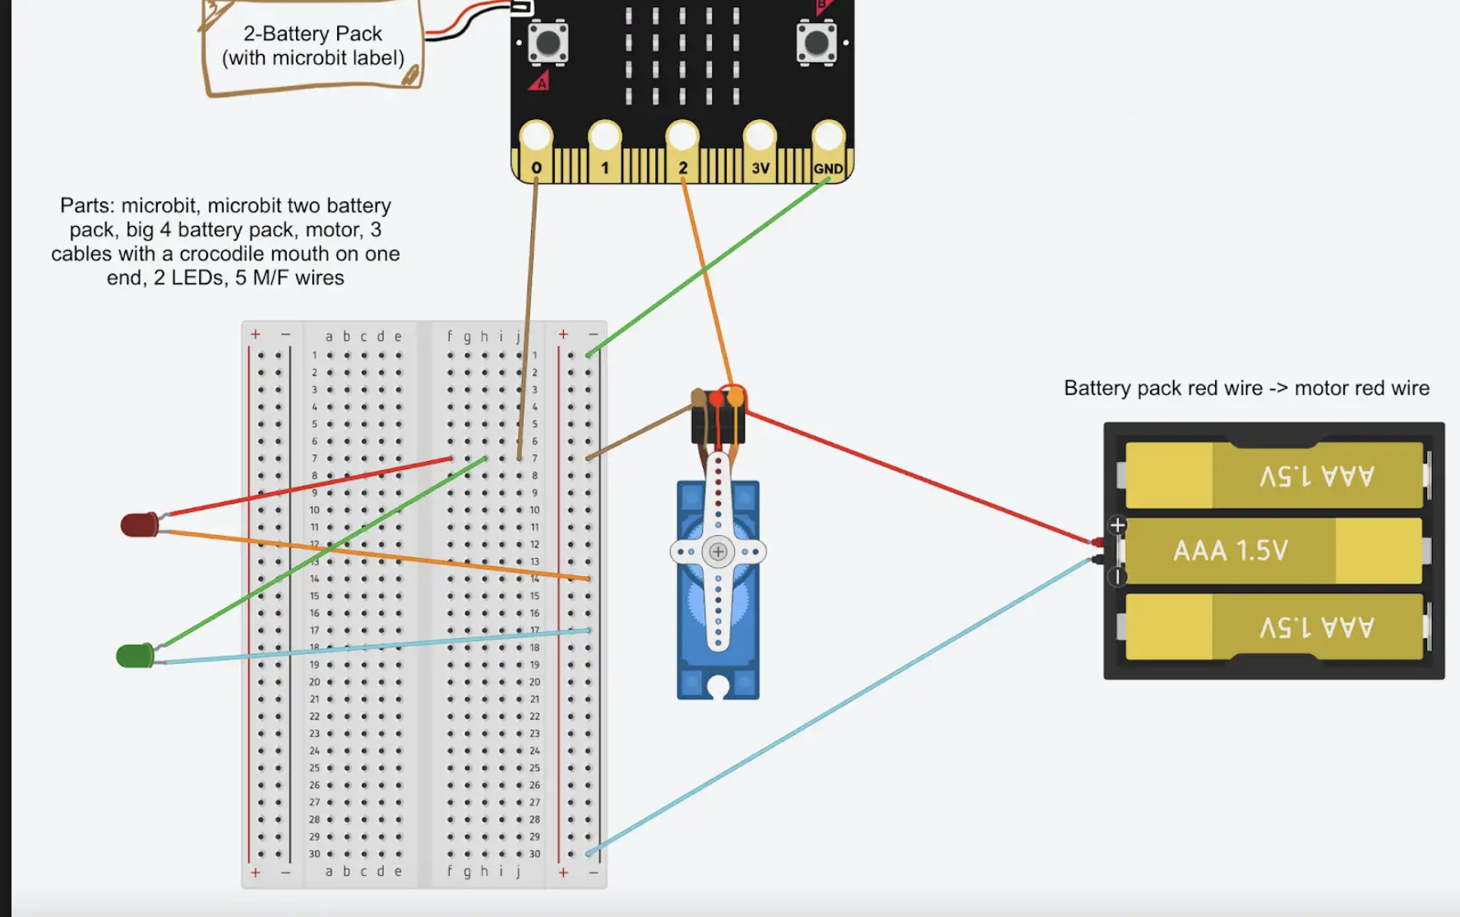

Steps with Breadboard

Parts Checklist
- Microbit
- Breadboard
- Big Battery Pack
- Small Battery Pack
- 4 Wires Alligator-Pin
- Motor
- 2 LEDs
- Breadboard
- 4 Pin/Hole Wires
  - 4 for LEDs to be attached to breadboard
  - 1 for Motor attached to battery pack
- 2 Pin/Pin Wires
  - 2 for Motor attached to breadboard

- LEDs
  - Take both LEDs and 4 Pin/Hole wires and attach all F ends to LED pins
    - Make note of which wires are the longer/shorter legs of LED
      - Ex: Yellow is the short leg, Green is the long leg
      - What does this mean?
        - Short leg (-) is goes to GND, Longer leg (+) goes to 3V
    - Take the wire attached to the shorter leg, and plug it into the negative column on the breadboard, in any row - do this for both LEDs
  - Connect LED 1
    - Take Alligator Clip 1, and clamp it to Pin 1 on Microbit
    - With other end of wire, plug it in to Row 1 on the breadboard
    - Take LED 1, and plug the remaining wire (which should be connected to the longer leg) and plug it into Row 1
  - Connect LED 2
    - Take Alligator Clip 2, and clamp it to Pin 2 on Microbit
    - With other end of wire, plug it in to Row 2 on the breadboard
    - Take LED 2, and plug its remaining wire (which should be connected to the longer leg) and plug it into Row 2
- Motor
  - Take 2 Pin/Pin wires, and 1 Pin/Hole wire and attach to the grouped wires coming from the motor
    - Keep track of which wire corresponds to each color of the grouped wires
    - The Pin/Hole wire should correspond to the RED wire coming from the motor
  - With the wire corresponding to the BLACK wire coming from the motor, plug it into the negative column on the breadboard
  - With the wire corresponding to the YELLOW wire coming from the motor, plug it into Row 3 on the breadboard
  - Take Alligator Clip 3, and clamp it on to Pin 0 on Microbit
  - With other end of the wire, plug it in to Row 3 on the breadboard
- GND
  - Take Alligator Clip 4, and clamp it to GND on Microbit
  - With other end of wire, plug in to negative column on breadboard in any row
- Batteries
  - Plug small battery back into microbit
  - Take the Pin/Hole wire attached to the red wire coming from the motor, and attach the F end to the Red wire coming from the big battery pack
  - Take the back wire coming from the big battery pack and plug it into the negative column on the breadboard in any row
  - Turn on the big battery pack

Steps without Full Breadboard

Parts Checklist
- Microbit
- Negative/Positive Column of the Breadboard
- Big Battery Pack
- Small Battery Pack
- 4 Wires Alligator-Pin
- Motor
- 2 LEDs
- Breadboard
- 5 Pin/Hole Wires
  - 4 for LEDs to be attached to breadboard
  - 1 for Motor attached to battery pack
- 1 Pin/Pin Wires
  - 1 for Motor attached to breadboard neg column
- 3+ Hole/Hole Wires
  - 2 for LED-MB
  - 1 for Motor-MB

- LEDs
  - Take both LEDs and 4 Pin/Hole wires and attach all F ends to LED pins
    - Make note of which wires are the longer/shorter legs of LED
      - Ex: Yellow is the short leg, Green is the long leg
      - What does this mean?
        - Short leg (-) is goes to GND, Longer leg (+) goes to 3V
    - Take the wire attached to the shorter leg, and plug it into the negative column on the breadboard, in any row - do this for both LEDs
  - Connect LED 1
    - Take Alligator Clip 1, and clamp it to Pin 1 on Microbit
    - With other end of wire, plug it in to Hole/Hole wire
    - Take LED 1, and plug the remaining wire (which should be connected to the longer leg) and plug it into the other end of the Hole/Hole wire
  - Connect LED 2
    - Take Alligator Clip 2, and clamp it to Pin 2 on Microbit
    - With other end of wire, plug it in to Hole/Hole wire
    - Take LED 2, and plug its remaining wire (which should be connected to the longer leg) and plug it into the other end of the Hole/Hole wire
- Motor
  - Take 1 Pin/Pin wire, 1 Alligator Clip-M wire, and 1 Pin/Hole wire and attach to the grouped wires coming from the motor
    - Keep track of which wire corresponds to each color of the grouped wires
    - The Pin/Hole wire should correspond to the RED wire coming from the motor
    - The Pin/Pin wire should correspond with the BLACK wire
    - The Alligator Pin should correspond with the YELLOW wire
  - With the wire corresponding to the BLACK wire coming from the motor, plug it into the negative column on the breadboard
  - With the wire corresponding to the YELLOW wire coming from the motor, clamp it on to Pin 0 of the microbit
  - Take Alligator Clip 3, and clamp it on to Pin 0 on Microbit
- GND
  - Take Alligator Clip 4, and clamp it to GND on Microbit
  - With other end of wire, plug in to negative column on breadboard in any row
- Batteries
  - Plug small battery back into microbit
  - Take the Pin/Hole wire attached to the red wire coming from the motor, and attach the F end to the Red wire coming from the big battery pack
  - Take the back wire coming from the big battery pack and plug it into the negative column on the breadboard in any row
  - Turn on the big battery pack

Steps with Ceibal’s Board

Parts Checklist
- Microbit
- Ceibal Board -
- Big Battery Pack
- Small Battery Pack
- 4 Wires Alligator-Pin
- Motor
- 2 LEDs
- Breadboard
- 4 Pin/Hole Wires
  - 4 for LEDs to be attached to breadboard
  - 1 for Motor attached to battery pack
- 2 Pin/Pin Wires
  - 2 for Motor attached to breadboard

- LEDs
  - Take both LEDs and 4 Pin/Hole wires and attach all F ends to LED pins
    - Make note of which wires are the longer/shorter legs of LED
      - Ex: Yellow is the short leg, Green is the long leg
      - What does this mean?
        - Short leg (-) is goes to GND, Longer leg (+) goes to 3V
    - Take the wire attached to the shorter leg, and plug it into row 10 of the board (just has to be same as wherever MB’s ground is) - do this for both LEDs
  - Connect LED 1
    - Take Alligator Clip 1, and clamp it to Pin 1 on Microbit
    - With other end of wire, plug it in to Row 1 on the breadboard
    - Take LED 1, and plug the remaining wire (which should be connected to the longer leg) and plug it into Row 1
  - Connect LED 2
    - Take Alligator Clip 2, and clamp it to Pin 2 on Microbit
    - With other end of wire, plug it in to Row 2 on the breadboard
    - Take LED 2, and plug its remaining wire (which should be connected to the longer leg) and plug it into Row 2
- Motor
  - Take 2 Pin/Pin wires, and 1 Pin/Hole wire and attach to the grouped wires coming from the motor
    - Keep track of which wire corresponds to each color of the grouped wires
    - The Pin/Hole wire should correspond to the RED wire coming from the motor
  - With the wire corresponding to the BLACK wire coming from the motor, plug it into row 10 of the board (just has to be same as wherever MB’s ground is)
  - With the wire corresponding to the YELLOW wire coming from the motor, plug it into Row 3 on the breadboard
  - Take Alligator Clip 3, and clamp it on to Pin 0 on Microbit
  - With other end of the wire, plug it in to Row 3 on the breadboard
- GND
  - Take Alligator Clip 4, and clamp it to GND on Microbit
  - With other end of wire, plug in to row 10 of the board
- Batteries
  - Plug small battery back into microbit
  - Take the Pin/Hole wire attached to the red wire coming from the motor, and attach the F end to the Red wire coming from the big battery pack
  - Take the back wire coming from the big battery pack and plug it into the negative column on the breadboard in any row
  - Turn on the big battery pack

Converting to ScratchJr Project

Steps with Breadboard

Parts Checklist
- Microbit
- Breadboard
- Big Battery Pack
- Small Battery Pack
- 4 Wires Alligator-Pin
- Motor
- 2 LEDs
- 4 Pin/Hole Wires
  - 4 for LEDs to be attached to breadboard
  - 1 for Motor attached to battery pack
- 2 Pin/Pin Wires
  - 2 for Motor attached to breadboard

- LEDs
  - Take both LEDs and 4 Pin/Hole wires and attach all F ends to LED pins
    - Make note of which wires are the longer/shorter legs of LED
      - Ex: Yellow is the short leg, Green is the long leg
      - What does this mean?
        - Short leg (-) is goes to GND, Longer leg (+) goes to 3V
    - Take the wire attached to the shorter leg, and plug it into the negative column on the breadboard, in any row - do this for both LEDs
  - Connect LED 1
    - Take Alligator Clip 1, and clamp it to Pin 1 on Microbit
    - With other end of wire, plug it in to Row 1 on the breadboard
    - Take LED 1, and plug the remaining wire (which should be connected to the longer leg) and plug it into Row 1
  - Connect LED 2
    - Take Alligator Clip 2, and clamp it to Pin 2 on Microbit
    - With other end of wire, plug it in to Row 2 on the breadboard
    - Take LED 2, and plug its remaining wire (which should be connected to the longer leg) and plug it into Row 2
- Motor
  - Take 2 Pin/Pin wires, and 1 Pin/Hole wire and attach to the grouped wires coming from the motor
    - Keep track of which wire corresponds to each color of the grouped wires
    - The Pin/Hole wire should correspond to the RED wire coming from the motor
  - With the wire corresponding to the BLACK wire coming from the motor, plug it into the negative column on the breadboard
  - With the wire corresponding to the YELLOW wire coming from the motor, plug it into Row 3 on the breadboard
  - Take Alligator Clip 3, and clamp it on to Pin 0 on Microbit
  - With other end of the wire, plug it in to Row 3 on the breadboard
- GND
  - Take Alligator Clip 4, and clamp it to GND on Microbit
  - With other end of wire, plug in to negative column on breadboard in any row
- Batteries
  - Plug small battery back into microbit
  - Take the Pin/Hole wire attached to the red wire coming from the motor, and attach the F end to the Red wire coming from the big battery pack
  - Take the back wire coming from the big battery pack and plug it into the negative column on the breadboard in any row
  - Turn on the big battery pack

